National Trends in Surgery for Sinonasal Malignancy: The Effect of Hospital Volume on Short-Term Outcomes

David Ouyang1, Ivan El-Sayed2, Sue S. Yom12

Institutions: 1. Department of Radiation Oncology, University of California, San Francisco, San Francisco, CA, United States, 2. Department of Otolaryngology-Head and Neck Surgery, University of California, San Francisco, San Francisco, CA, United States

Background: Sinonasal carcinomas are rare, highly morbid neoplasms originating in the nasal cavity and paranasal sinuses. The mainstay of treatment over the past two decades has been a combination of surgery, radiation, and chemotherapy. We sought to characterize trends in the initial management of sinonasal malignancy with a particular focus on the impact of hospital volume on surgical care and outcomes.

Methods: A retrospective cohort study was conducted examining time trends among patients admitted for surgical resection of sinonasal malignancy in the National Inpatient Sample (NIS) between 1988 and 2009. Subset analysis of high risk cases was performed on patient cohorts with skull base involvement, orbital or maxillary sinus involvement, or who underwent neck dissection. Patient characteristics as well as hospital attributes were correlated with patient morbidity and mortality.

Results: Over the course of 22 years, we identified 3850 cases of sinonasal surgery patients from 879 hospitals. 24.3% of patients had complications ranging from infections, cardiopulmonary complications, neuropathy, visual disturbances, and electrolyte abnormalities and 0.8% of hospitalizations resulted in mortality. High risk cases with skull base involvement, orbital or maxillary sinus involvement, or including neck dissection had more complications (29.4% vs. 23.2%, p < 0.001) and a longer length of stay (9.34 days vs. 6.12 days). More aggressive surgical management increased with more neck dissection and CNS involvement over time.

Nine hospitals averaged more than 10 cases per year, accounting for 7.6% (294) of all sinonasal surgeries. These high-volume centers were predominantly large (88.8%), urban (88.8%), teaching (88.8%) institutions and performed more high risk cases – accounting for 11.9% of cases including neck dissection, 17.8% of cases with orbital involvement, and 9.1% of cases with skull base involvement. Over the time period studied, a greater proportion of cases were recently performed at high-volume centers.

Conclusions: This study characterizes current trends in the initial management of sinonasal cancer. There is an increased likelihood that complicated surgeries are performed at higher-volume hospitals which also entails a higher complication rate. High risk cases resulted in higher rates of complications but were not associated with a higher mortality rate.

Qs:

I don’t think more than 5 cases per year should count as high volume. Is there a cohort that performed more than 10 per year? Were complication rates less or more for the high risk cohort operated at very high volume hospitals?

DO: There were only 10 hospitals in the database that had 10 or greater cases per year vs. 32 hospitals with >5. I’ve changed the abstract to reflect it with numbers changed as well, however I feel like it makes a little more of impact with >5. The #1 hospital is categorized as rural in the database, so it would be 89% urban vs. 97% urban. Complication rate for high risk cohort was 33.3% at high volume vs. 29.4% at low volume.

Were more high risk surgeries performed over time? In other words, surgical techniques have become more advanced so the number of high risk surgeries might be going up?

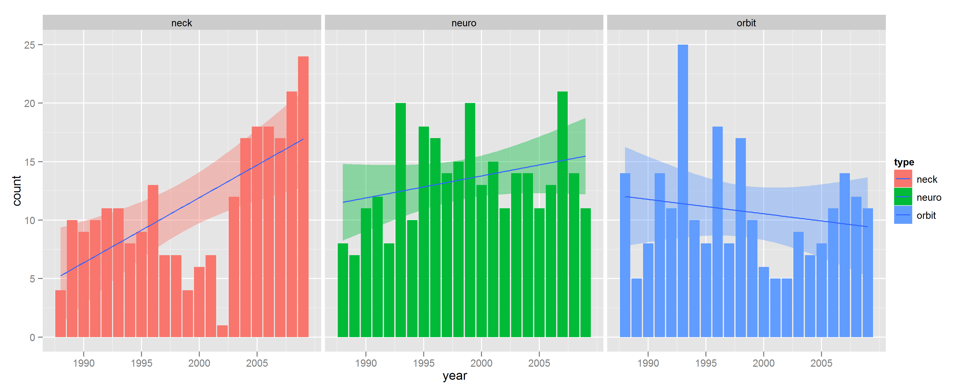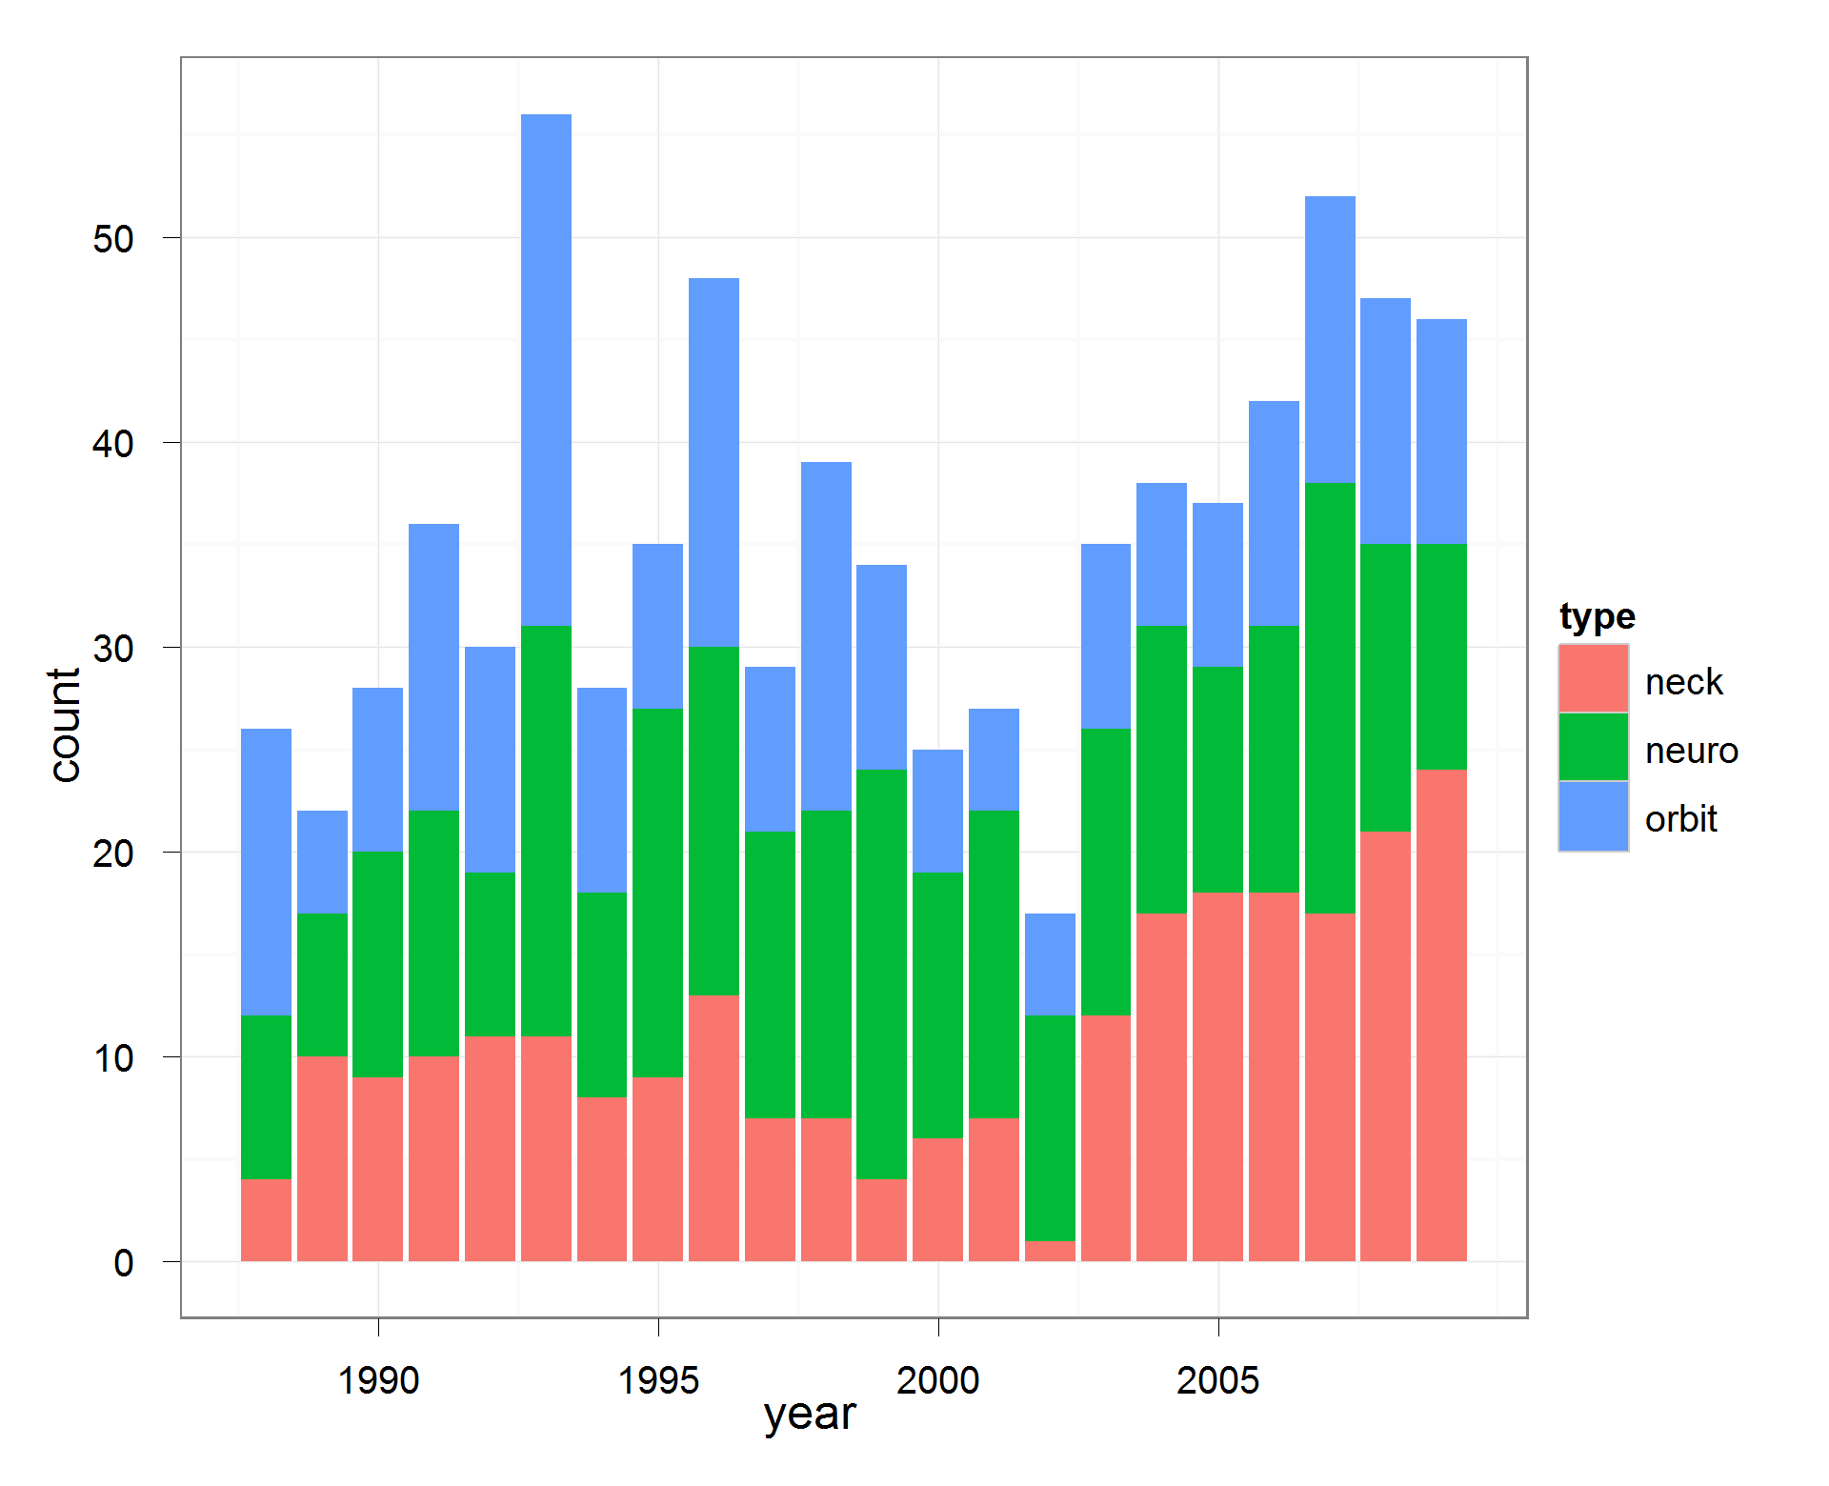

There is a slight trend towards more high risk surgeries in general, however there is a more significant trend of more neck dissection.

Among high risk surgeries that were performed, what was the complication rate for low volume, intermediate volume, and high volume hospitals? Is there any way to find out whether these complications were minor or severe?

Complication rate was generally similar, no time trend.

|  |  |  |  |  |  |  |  |
| --- | --- | --- | --- | --- | --- | --- | --- |
| **Table 4.** Complications of Sinonasal Cancer Surgery | | | | | | | |
|  | **Total** | **High-Volume Centers** | | **Low-Volume Centers** | | | **Pa** |
| Deaths, n (%) | 30 (0.8) | 4 (0.4) | | 26 (0.9) | | 0.122 | |
|  |  |  | |  |  | | |
| Infectious, n (%) |  |  | |  | | 0.119 | |
| Surgical Site Infection | 70 (1.8) | 14 (1.3) | | 56 (2.0) | |  | |
| Urinary Tract Infections (UTIs) | 71 (1.8) | 16 (1.5) | | 55 (2.0) | |  | |
| Pneumonia | 30 (0.8) | 9 (0.8) | | 21 (0.8) | |  | |
| Unspecified Postop Infection | 17 (0.4) | 3 (0.2) | | 14 (0.5) | |  | |
|  |  |  | |  | |  | |
| Cardiopulmonary, n (%) |  |  | |  | | 0.024b | |
| Stroke | 16 ((0.4) | 8 (0.8) | | 8 (0.3) | |
| Cardiac Arrest | 8 (0.2) | 1 (0.1) | | 7 (0.3) | |  | |
| Other Cardiac Complications | 456 (11.8) | 127 (12.0) | | 329 (11.8) | |  | |
| Pulmonary Complications | 239 (6.2) | 87 (8.2) | | 152 (5.4) | |  | |
|  |  |  | |  | |  | |
| Other, n (%) |  |  | |  | |  | |
| Neuropathies  Visual Impairment | 51 (1.3) | 13 (1.2) | | 38 (1.4) | | 0.861 | |
| 76 (2.0) | 20 (1.9) | | 56 (2.0) | | 0.908 | |
| Hemorrhage | 46 (1.2) | 12 (1.1) | | 34 (1.2) | | 0.953 | |
| Electrolyte Abnormalities | 312 (8.1) | 110 (10.4) | | 202 (7.2) | | 0.002b | |
|  |  |  |  | | |  | |
| **Total Complications** | **1392 (36.9)** | 424 (40.0) | | 998 (35.8) | | 0.018b | |
| aChi Square Test Comparing High-Volume and Low-Volume Centers. b P < 0.05 | | | | | | | |

What was the average hospital stay for high risk cases versus lower risk cases? For high volume versus low or intermediate volume hospitals?

Average LOS for high volume centers was 7.29 days, with high risk cohort being 9.73 days.

Average LOS for low volume center was 6.72 days, with high risk cohort being 9.34 days.